**Database Management System**

**LAB Practical – 2 & 3**

**Creating tables:**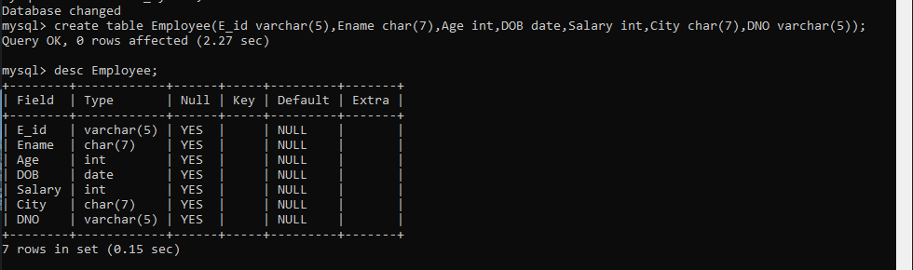

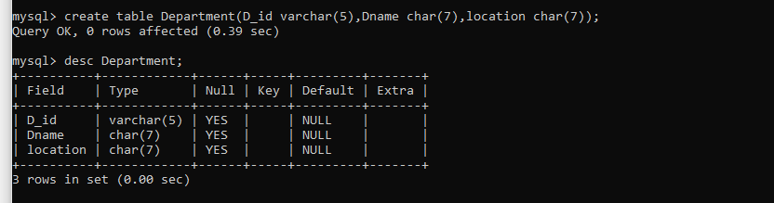

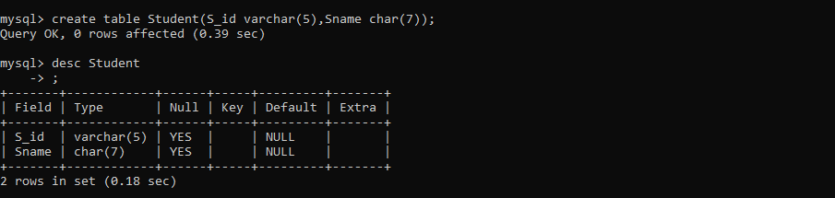

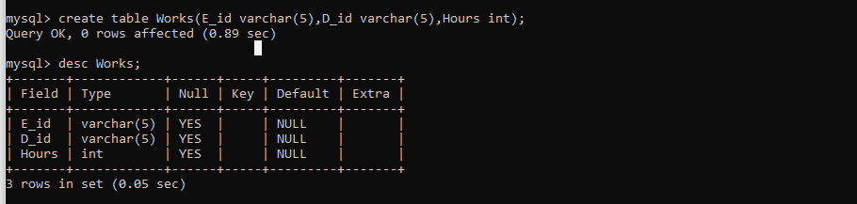

**Q-1 Insert 5 rows in each table.**

**Employee:**

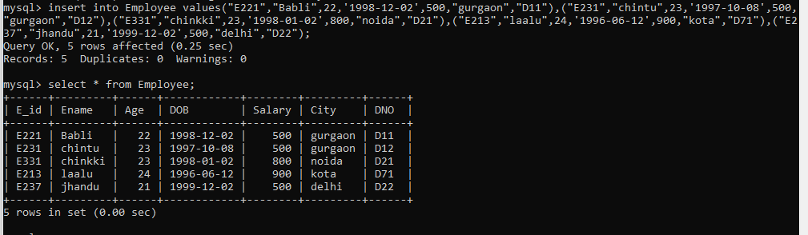

**Department:**

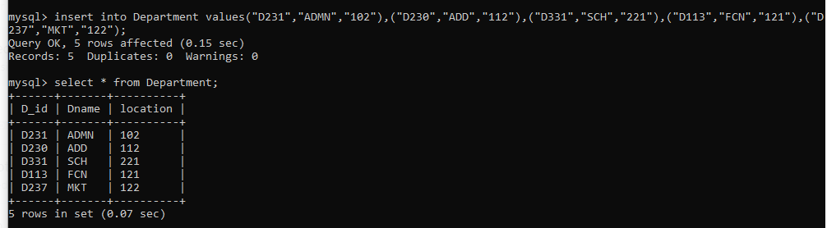

**Student:**

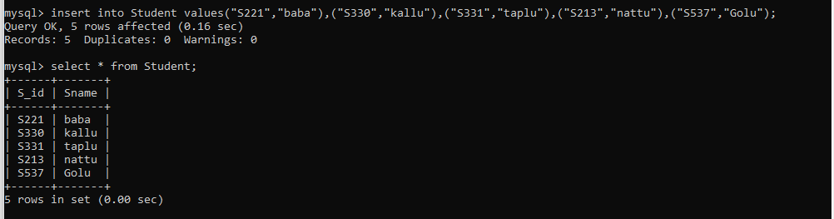

**Works:**

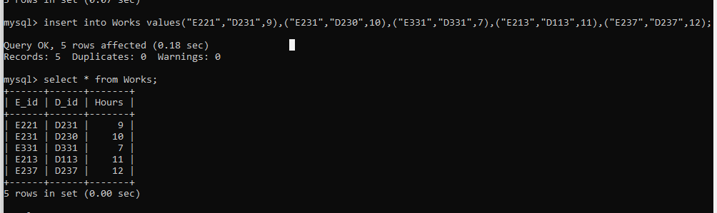

**Q-2 Increase the size of column City to 10 in Employee.**

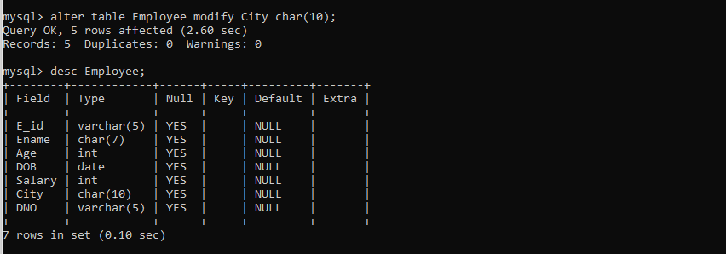

**Q-3 Rename table Department to Office.**

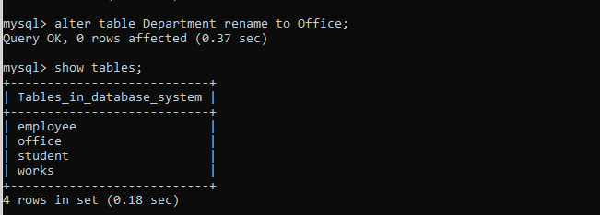

**Q-4 Drop the table Student.**

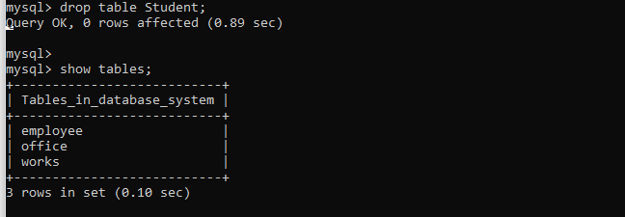

**Q-5 Delete Data of Employee working in D11.**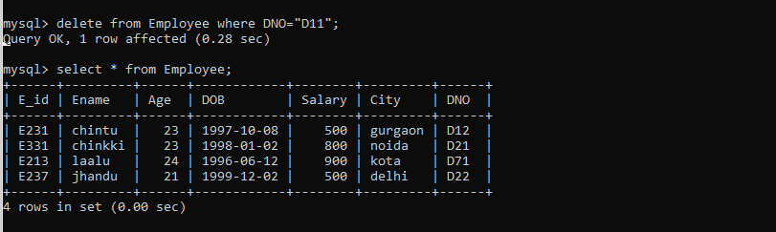

**Q-6 Raise the Salary by 10% whose salary is less 700.**

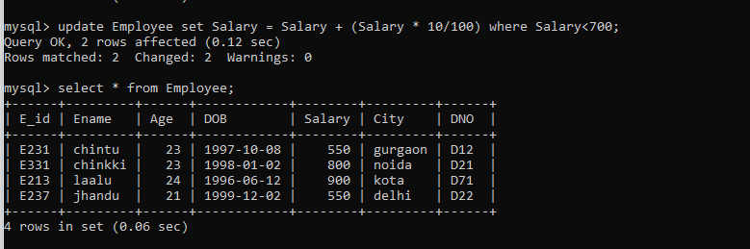

**Q-7 Add a column State char (10) in Employee.**

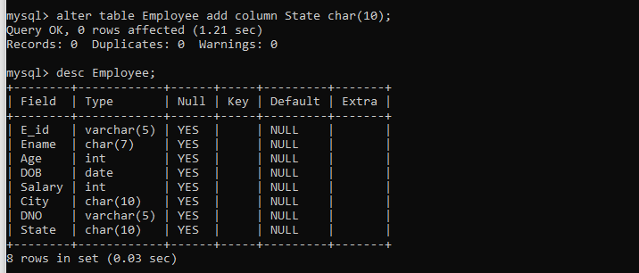

**Q-8 Insert values into newly added column.**

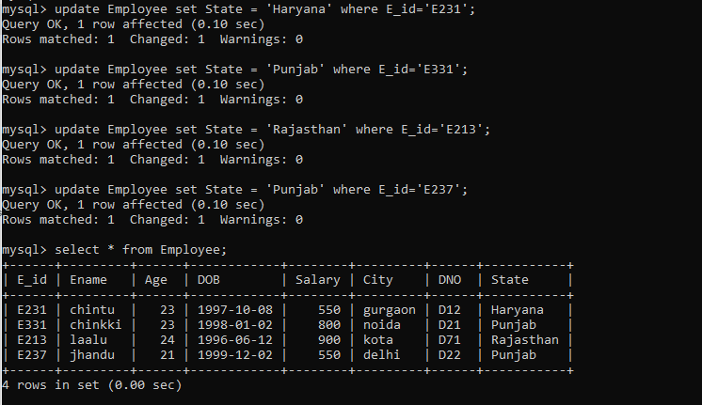

**Q-9 Change name City in Employee to Address.**

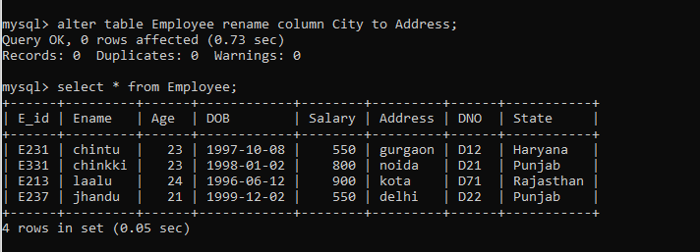

**Q-10 Add column manager_id varchar (10) in table Office.**

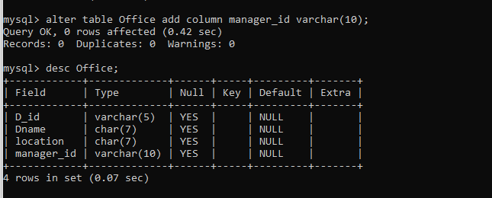

**Q-11 Enter values in newly added column.**

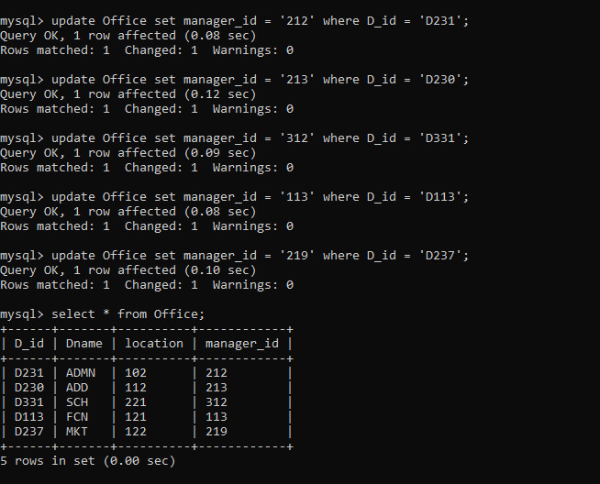

**Q-12 Drop Column Age in Employee.**

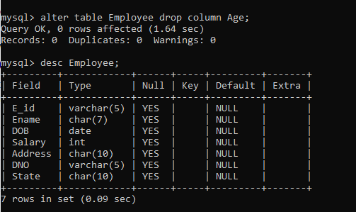

**LAB – 2**

**Q-1 List down the employees who are having salary greater than equal to 500 and less then equal to 800.**

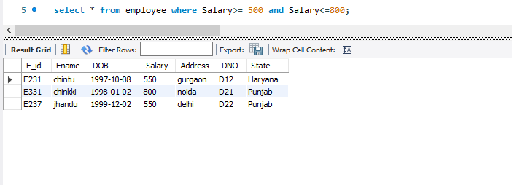

**Q-2 List down the department offices located – 102, 121.**

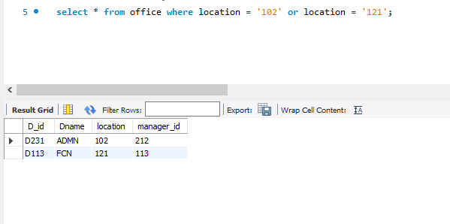

**Q-3 List the Eid, name of those employees whose name starts with letter c and ends with letter u.**

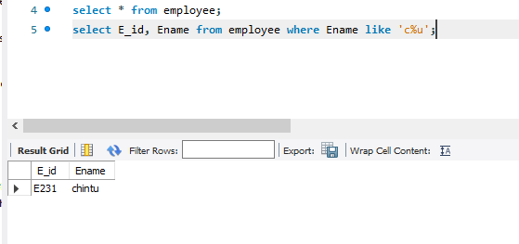

**Q-4 List those employees who are having age greater than 20 yrs and are residing in Delhi.**

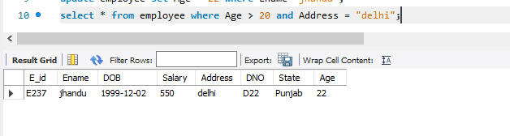

**Q-5. List the Eid, age, name of employees living in either Noida, Delhi or Gurgaon using in predicate.**

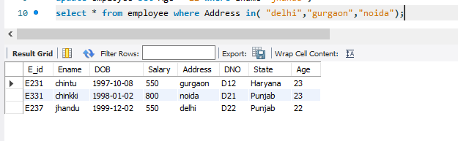

**Q-6. List the details of the departments whose name has second character as d or second last character as c**

